Creating a Simple Photo Gallery

Requirements:

* Add pictures from file with no limit set on the number of pictures that can be added
* Navigate left and right through the pictures with buttons
* Have an automatic slide show that sequences through the pictures
* Have the delay between pictures variable

# Step 1.

Create a new C# Windows Forms App called “PhotoViewer”

Add a Picture box to the centre of the form

Add a button either side of the picture box. The need to be named btn_left and btn_right and the text on them needs to be a < and a >

Add a button above the picture box. This is btn_add and needs the text “add picture”

Add a button under the picture box. This is btn_slideShow and needs the text “Start Slide Show”

Add a numericUpDown control and label it “Delay”

Add an openFileDialog to the form

Add a timer to the form. Set the timer property enabled to false and the interval to 1000

# Step 2.

Add the code to store the images. We are going to use a list so we can add as many images as we like, one at a time. We also need a pointer to the current pictures location in the list.

Note, these are global (for this class) so go right at the top.

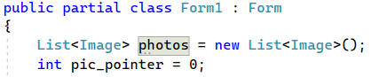

# Step 3.

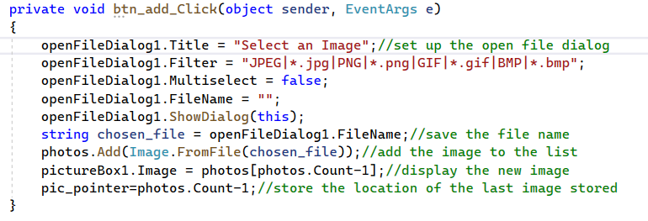Add the code to load the photos. Double click the add button to create the handler.

Now test your code. It should add a photo and display it. You can do this several times and it should show the new photo each time.

# Step 4.

Now we’re going to add the functions for the left and right buttons. Click on both in turn to generate the event handlers.

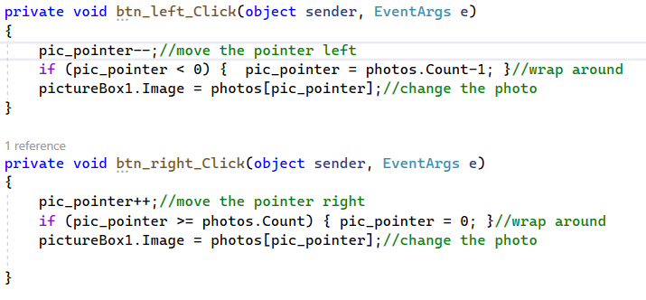

Test the code again.

# Step 5

The slide show function. I want to use the same button for starting and stopping the slideshow so I’ll have to change the text on it in my program. I also want to modify the numericalUpDown control.

First, set the numericalUpDown minimum value in its properties to 1. Set the maximum to 5. Set its value to 1.

Next, code the button as follows. Generate the handler first as before.

Now, add the code for the timer tick (if the handler isn’t there double click the timer to generate it).

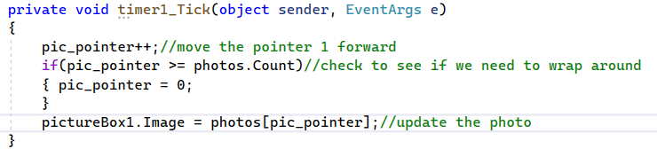

Finally, add the code for the numerical UpDown control. First we’ll need a handler for its “valueChanged” event. You will need to go to the controls properties and click the events button (it looks like a lightning bolt. Find valueChanged and click it to generate the handler code.

Add this final bit and test it.

NOTE: YOU CAN NOT JUST TYPE THE HEADERS FOR THE EVENT HANDLERS. They must be generated from the form design by either clicking on the control for a click event or by going to the list of available events for that control.

If you accidentally generate a header you don’t want you MUST go to the list of available events for that control, right click the event you want rid of and select reset. Doing it any other way will break your code and you may have to start again from scratch.